Lebanese American University

Department of Computer Science & Mathematics

CSC 458 – Game Programming



Technical Design Document

Data: 22/04/2021

Project: The Quest

By:

**Flowchart:**

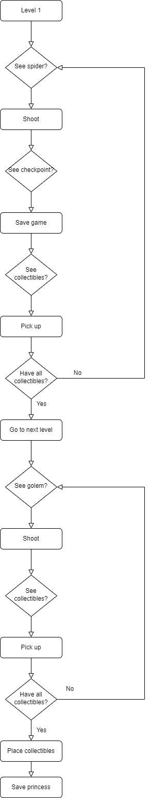

**UML Class Diagrams:**

1) SpiderBase.cs, SpiderPatrolScript.cs, SpiderAttack.cs, SpiderWait.cs, Follow.cs: These scripts control the animations related to the spider (using FSM). The base script inherits from StateMachineBehavior and the specific scripts inherit from the base one.

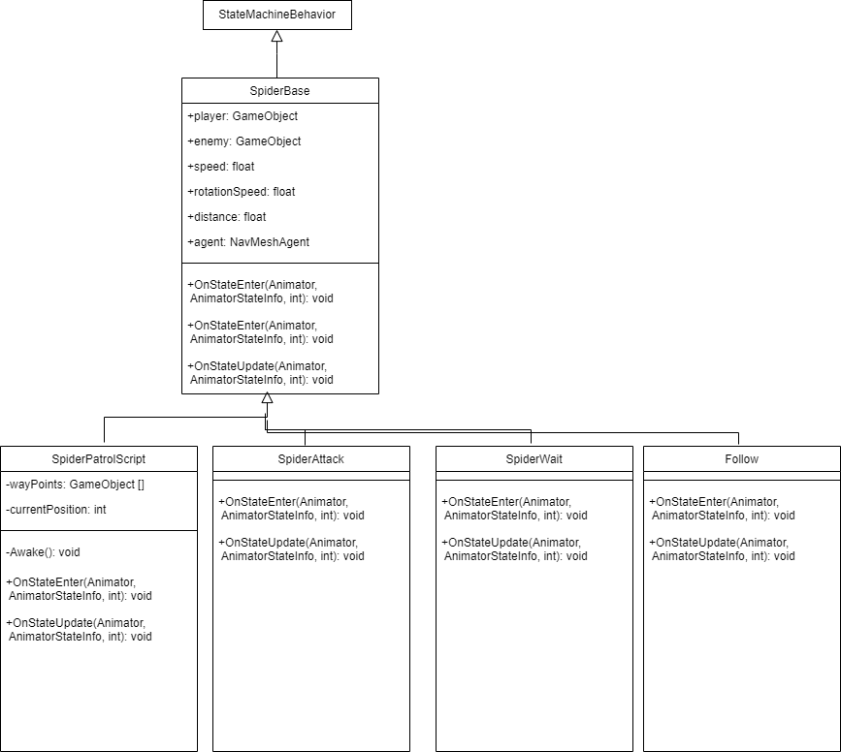

2) Waypoints.cs: This script uses gizmos to show the waypoints and the path between them.

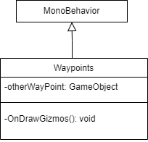

3) Story.cs: This script shows the story at the beginning of the game.

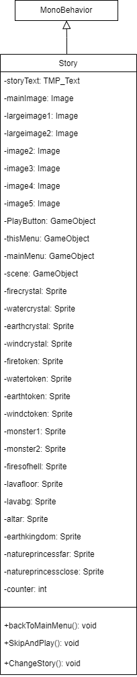

4) EnemyAI.cs: This script controls the animations related to the golem (using behavior trees). It also draws a cube around the enemy by gizmos.

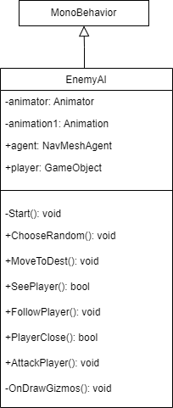

5) FinalCamera.cs: This script controls the rotation of the final camera when the player wins.

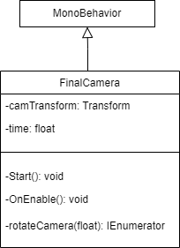

6) Load.cs: This script controls loading the player to checkpoint after he loses.

%3CmxGraphModel%3E%3Croot%3E%3CmxCell%20id%3D%220%22%2F%3E%3CmxCell%20id%3D%221%22%20parent%3D%220%22%2F%3E%3CmxCell%20id%3D%222%22%20value%3D%22-OnEnable()%3A%20void%26%2310%3B%22%20style%3D%22text%3Balign%3Dleft%3BverticalAlign%3Dtop%3BspacingLeft%3D4%3BspacingRight%3D4%3Boverflow%3Dhidden%3Brotatable%3D0%3Bpoints%3D%5B%5B0%2C0.5%5D%2C%5B1%2C0.5%5D%5D%3BportConstraint%3Deastwest%3Brounded%3D0%3Bshadow%3D0%3Bhtml%3D0%3B%22%20vertex%3D%221%22%20parent%3D%221%22%3E%3CmxGeometry%20x%3D%22202%22%20y%3D%22220%22%20width%3D%22203%22%20height%3D%2230%22%20as%3D%22geometry%22%2F%3E%3C%2FmxCell%3E%3C%2Froot%3E%3C%2FmxGraphModel%3E

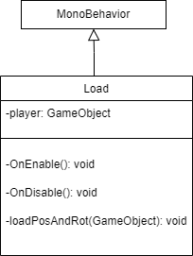

7) Enemy.cs: This script controls the enemy and draws a cube around it using gizmos.

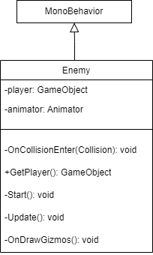

8) PauseScript.cs: This script allows the player to pause, resume and quit the game.

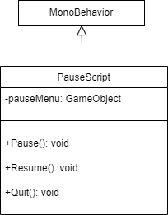

9) MainMenu.cs: This script controls the main menu.

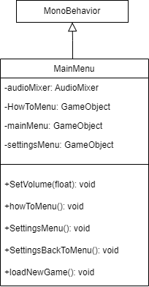

10) Bullet.cs: This script controls things related to the bullet such as audio and speed.

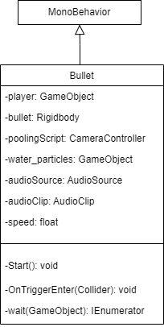

11) animationEvent.cs: This script controls the use of animation sound.

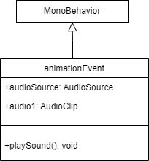

12) TextUI.cs: This script controls timer before respawning.

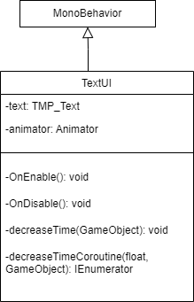

13) MeterSO.cs: This script is used to handle the scriptable objects.

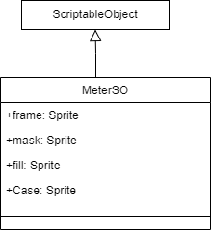

14) MeterDisplay.cs: This script is used to assign the attributes of a scriptable object to the game object that refers to it.

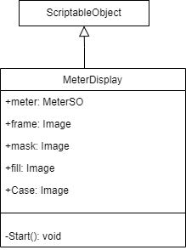

15) MeterDisplay.cs: This script is used to assign the attributes of a scriptable object to the game object that refers to it.

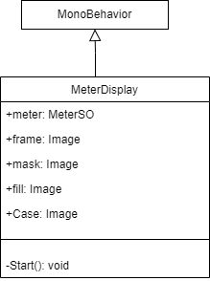

16) CheckpointGizmos.cs: This script is used to draw a cube around the checkpoint.

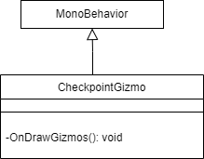

17) GameManager.cs: This script is used to play audio.

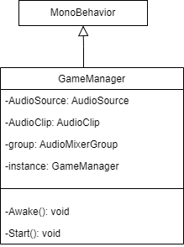

18) CameraController.cs: This script is used to control the player, its animation, camera and bullets.

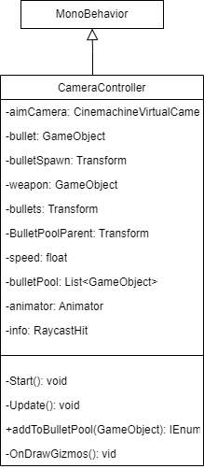

19) Player.cs: This script is one of our main scripts on the player. It handles the various UI settings, the playing of audio, the collection of items and damage on player.

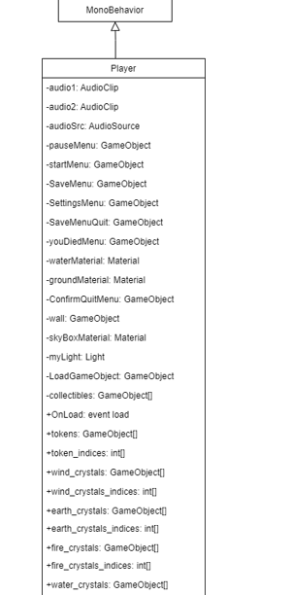

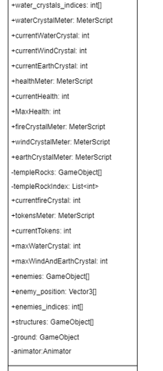

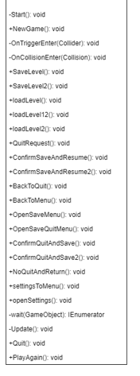

20) SaveSystem.cs: This script is used to save and load data.

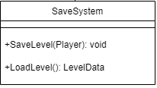

21) SaveSystem2.cs: This script is used to save and load data in level 2.

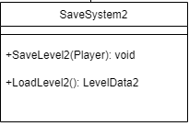

22) LevelData.cs: This script is used to make a level data class for level 1.

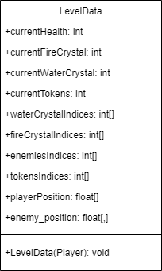

23) Level2Data.cs: This script is used to make a level data class for level 2.

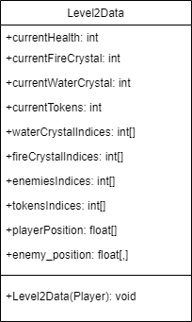

%3CmxGraphModel%3E%3Croot%3E%3CmxCell%20id%3D%220%22%2F%3E%3CmxCell%20id%3D%221%22%20parent%3D%220%22%2F%3E%3CmxCell%20id%3D%222%22%20value%3D%22%2Bplayer%3A%20GameObject%26%2310%3B%22%20style%3D%22text%3Balign%3Dleft%3BverticalAlign%3Dtop%3BspacingLeft%3D4%3BspacingRight%3D4%3Boverflow%3Dhidden%3Brotatable%3D0%3Bpoints%3D%5B%5B0%2C0.5%5D%2C%5B1%2C0.5%5D%5D%3BportConstraint%3Deastwest%3Brounded%3D0%3Bshadow%3D0%3Bhtml%3D0%3B%22%20vertex%3D%221%22%20parent%3D%221%22%3E%3CmxGeometry%20x%3D%22202%22%20y%3D%22146%22%20width%3D%22203%22%20height%3D%2226%22%20as%3D%22geometry%22%2F%3E%3C%2FmxCell%3E%3C%2Froot%3E%3C%2FmxGraphModel%3E

%3CmxGraphModel%3E%3Croot%3E%3CmxCell%20id%3D%220%22%2F%3E%3CmxCell%20id%3D%221%22%20parent%3D%220%22%2F%3E%3CmxCell%20id%3D%222%22%20value%3D%22%2Bplayer%3A%20GameObject%26%2310%3B%22%20style%3D%22text%3Balign%3Dleft%3BverticalAlign%3Dtop%3BspacingLeft%3D4%3BspacingRight%3D4%3Boverflow%3Dhidden%3Brotatable%3D0%3Bpoints%3D%5B%5B0%2C0.5%5D%2C%5B1%2C0.5%5D%5D%3BportConstraint%3Deastwest%3Brounded%3D0%3Bshadow%3D0%3Bhtml%3D0%3B%22%20vertex%3D%221%22%20parent%3D%221%22%3E%3CmxGeometry%20x%3D%22202%22%20y%3D%22146%22%20width%3D%22203%22%20height%3D%2226%22%20as%3D%22geometry%22%2F%3E%3C%2FmxCell%3E%3C%2Froot%3E%3C%2FmxGraphModel%3E

Note: We considered some Unity3D data types as private.